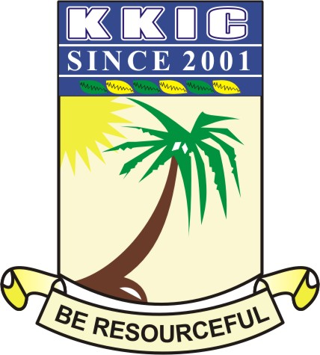

NAME
SUBJECT | CIVIC EDUCATION (THEORY) | CLASS | SS 2 | DURATION | 1 HOUR

SECTION B: THEORY (40Marks)
Answer question 1 and any other three questions of your choice

- Write short notes on the following skills necessary for resolving inter-communal conflicts.
- Arbitration
- Mediation
- Special peace-keeping taskforce
- Compensation 8 MARKS

(b) Mention four function of political parties. 2 MARKS

- (a) Discuss 5 constraints of good parenthood. 5MARKS
(b) Mention skills that promote interpersonal relationship 5MARKS

- Write 4 characteristics of communal society 4 MARKS
(b) Inter-communal relationship has various activities. Discuss any 3 activities. 6 MARKS

- (a) Write the full meaning of the following:
- NAFDAC
- NDLEA
- NSCDC
- LASTMA 4 MARKS
(b) List 6 roles of LASTMA 6 MARKS

- (a) Discuss any 5 types of interpersonal relationship 5 MARKS
(b) Define the term inter-communal relationship 2 MARKS
(c) List 3 importance of employment 3 MARKS

6. Explain four importance of responsible parenthood to national development 4 MARKS
(b) List 6 duties of pedestrians. 6 MARKS

